41.4: The 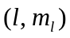 combinations are (0, 0), (1, 0), 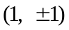, (2, 0), 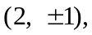 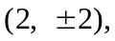 (3, 0), a total of 25.
b) Each state has the same energy ( is the same), 